**#SIR model to simulate leaf curl epidemic in chili; S-susceptible host, I-infectious host, R-post-infectious or removed**

#S and I

library(mosaic)

library(MosaicCalc)

Host=integrateODE(dS~-a*V*S,dI~a*V*S,a=0.9, S=1,V=0.1,I=0,tdur=list(from=0,to=20))

plotFun(Host$S(t)~t,t.lim=range(0,20))

plotFun(Host$I(t)~t,t.lim=range(0,20),add=TRUE,col="Red")

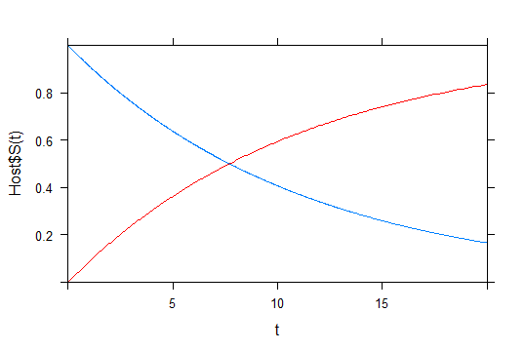

#Effect of immigration rate (virulifeorus vector population)on epidemic level (I and V population)

Host=integrateODE(dI~a*V*S, dV~(b*I*(1-V)/(K+1-V))+iv-ev-u*V,a=0.10,b=0.70,K=2.8,iv=0.2,u=0.34,ev=0.005,S=1.0, V=0.01,I=0.1,tdur=list(from=0,to=20))

#a=transmission eff,b=acquisition rate, iv=immigration rate, ev=emigration rate, K=Michaelis-Menten, u=death rate

plotFun(Host$I(t)~t,t.lim=range(0,20), xlim=c(0,20), ylim=c(0,1.0))

plotFun(Host$V(t)~t,t.lim=range(0,20),add=TRUE,col="Red")

---------------------------------------------------------------****---------------------------------------------------------

For iv=0.2

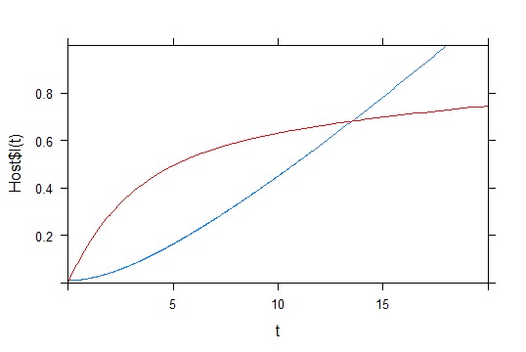

For iv=0.05

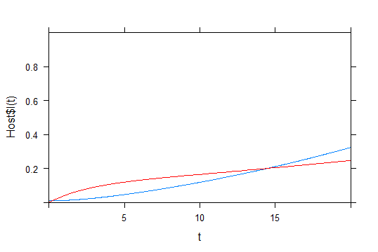

For iv=0.03

